

Semester One Examination, 2018

Question/Answer booklet

Yr 12 SPECIALIST
UNIT 3

Section Two:

Calculator-assumed

Your Name_________________________________________

Your Teacher’s Name_________________________________

Time allowed for this section
Reading time before commencing work: ten minutes
Working time: one hundred minutes

Materials required/recommended for this section
To be provided by the supervisor
This Question/Answer booklet
Formula sheet (retained from Section One)

To be provided by the candidate
Standard items: pens (blue/black preferred), pencils (including coloured), sharpener, correction fluid/tape, eraser, ruler, highlighters

Special items: drawing instruments, templates, notes on two unfolded sheets of A4 paper, and up to three calculators approved for use in this examination

Important note to candidates
No other items may be taken into the examination room. It is your responsibility to ensure that you do not have any unauthorized material. If you have any unauthorized material with you, hand it to the supervisor before reading any further.

Structure of this paper

Section | Number of questions available | Number of questions to be answered | Working time (minutes) | Marks available | Percentage of examination
Section One:  Calculator-free | 8 | 8 | 50 | 50 | 35
Section Two:  Calculator-assumed | 21 | 21 | 100 | 95 | 65
 |  |  |  | Total | 100

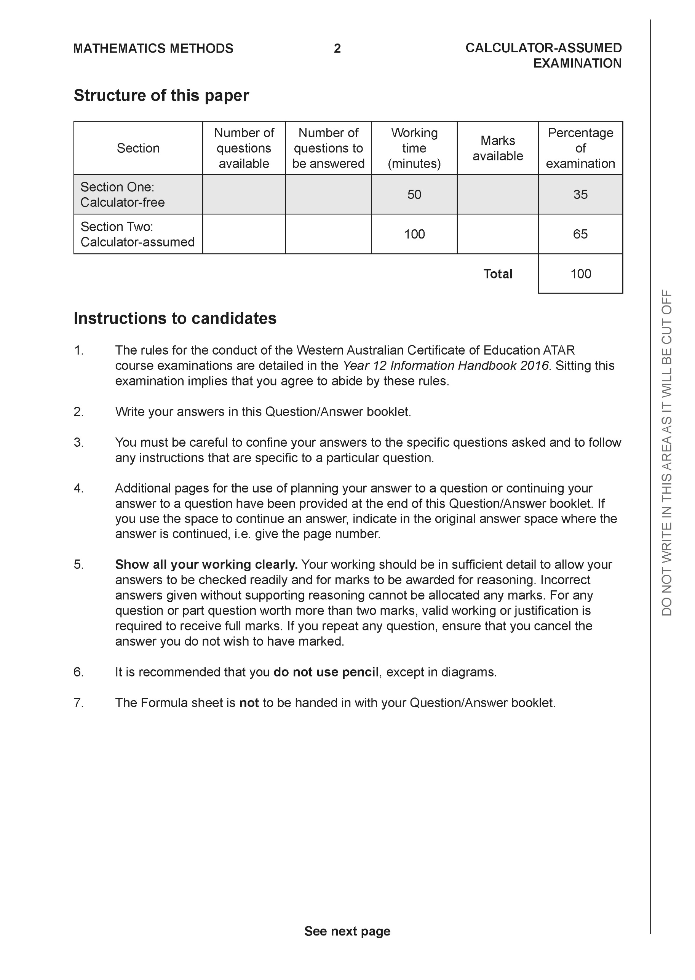

Section Two: Calculator-assumed (95 Marks)

This section has 13 questions. Answer all questions. Write your answers in the spaces provided.

Spare pages are included at the end of this booklet. They can be used for planning your responses and/or as additional space if required to continue an answer.
● Planning: If you use the spare pages for planning, indicate this clearly at the top of the page.
● Continuing an answer: If you need to use the space to continue an answer, indicate in the original answer space where the answer is continued, i.e. give the page number. Fill in the number of the question that you are continuing to answer at the top of the page.

Working time: 100 minutes.

Question 9 (4 marks)

Using vectors and the vector property , prove the following inequality

Question 10 (9 marks)

Consider the following system of linear equations where are constants.

Determine the values of :
(a) for which there is a unique solution (4 marks)

(b) for which there are infinite solutions. (3 marks)

(c) for which there are no solutions. (2 marks)

Question 11 (4 marks)
Consider the plane as shown below.

Determine the distance of point P from the plane to two decimal places.

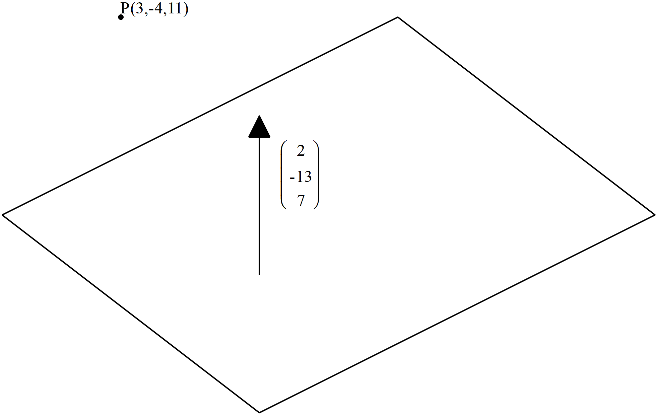

Question 12 (4 marks)

Given that use cross product to determine the distance of point P from the line to one decimal place.

Question 13 (4 marks)

The three vertices of a triangle have position vectors . Given that
Show that the area of the triangle is given by

Question 14 (6 marks)

Consider the polynomial where are real constants. Determine the values of given the following information for
is a factor of .
When is divided by there is a remainder of 165
and

575=(x+2)5(23)

Question 15 (9 marks)

At noon a rocket is launched from position km with a velocity of km/h.
Two hours later a second rocket is launched from position km with a velocity of km/h.
Assume that both rockets move with constant velocity at all times and that the rockets
do not collide.

(a) Determine the distance between the rockets at 2:30pm that day to one decimal place
(3 marks)

(b) Determine the times that the distance between the rockets is less than 50 km.
(4 marks)

(c) Determine the distance of closest approach and the time that this occurs. (2 marks)

Question 16 (9 marks)

Consider the complex numbers drawn in the complex plane below.

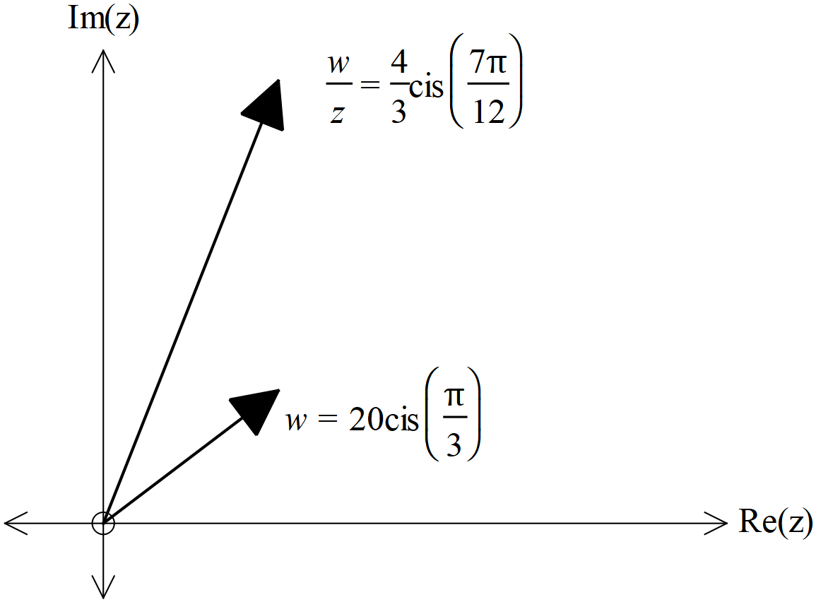
(a) Determine the exact value of in the form of (3 marks)

Consider the equation
where and

(b) Represent the above equation as a triangle in the complex plane below (3 marks)

Cont-

(c) Hence or otherwise solve for to one decimal place. (3 marks)

Question 17 (9 marks)

Consider a sphere with centre and radius of units.

(a) Write down the vector equation for this sphere (2 marks)

Consider a line parallel to vector and containing the point
where is a constant.

(b) Write down the vector equation of the line in terms of . (2 marks)

(c) Determine the possible values of , to 2 decimal places, if the line is a tangent to the sphere..
(5 marks)

Question 18 (11 marks)

A particle moves with acceleration at time seconds. The initial velocity is and initial displacement of .

(a) Determine the time(s),, that the particle is travelling parallel to the y axis.
(4 marks)

(b) Determine the first two times that the particle crosses the y axis. (4 marks)

(c) Determine the cartesian equation of the path of a new particle with the following position vector (3 marks)

Question 19 (9 marks)

Consider the function where and
are positive constants with

(a) Given that the inverse function does exist obtain an expression for
in terms of (3 marks)

(b) Given that there is only one point where determine the x value
in terms of (3 marks)

(c) Given that and ,
determine the function in terms of (3 marks)

Question 20 (11 marks)

Consider drawn below, where each face is a parallelogram. Let , and with perpendicular to plane containing vectors .

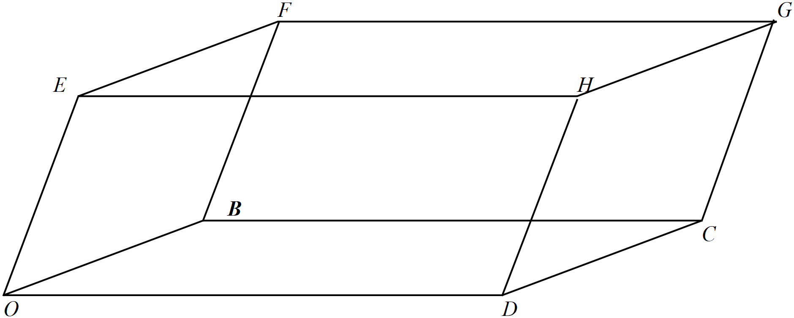

(a) Express each of the vectors in terms of
(4 marks)

(b) Express in terms of (4 marks)

Cont-
(c) Hence show that
(3 marks)

Question 21 (6 marks)
Consider the region defined by in the complex plane.

(a) Sketch the region on the axes below. (3 marks)
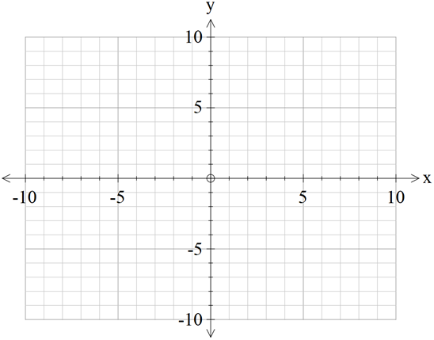
Re(z)
Im(z)

(b) Given that , determine the minimum value of
In the region in (a).(Give to two decimal places) (3 marks)

Additional working space
Question number:

